Document for REpresentational State Transfer Web Service
Prepared By: Garun Kumar Mishra
Date: 2017-04-04

Representational State Transfer(REST) Web Services:
=>REST stands for REpresentational State Transfer, was first introduced by Roy Fielding in his thesis"Architectural Styles and the Design of Network-based Software Architectures" in 2000.
=>REST is an architectural style. HTTP is a protocol which contains the set of REST architectural constraints.

REST Fundamentals
- Everything in REST is considered as a resource.
- Every resource is identified by an URI.
- Uses uniform interfaces. Resources are handled using POST, GET, PUT, DELETE operations which are similar to Create, Read, update and Delete(CRUD) operations.
- Be stateless. Every request is an independent request. Each request from client to server must contain all the information necessary to understand the request.
- Communications are done via representations. E.g. XML, JSON

RESTful Web Services
RESTful Web Services have embraced by large service providers across the web as an alternative to SOAP based Web Services due to its simplicity. This post will demonstrate how to create a RESTful Web Service and client using Jersey framework which extends JAX-RS API. Examples are done using Eclipse IDE and Java SE 6.

Creating RESTful Web Service
- In Eclipse, create a new dynamic web project called "RESTfulWS"
- Download Jersey zip bundle from here. Jersey version used in these examples is 1.17.1. Once you unzip it you'll have a directory called "jersey-archive-1.17.1". Inside it find the lib directory. Copy following jars from there and paste them inside WEB-INF -> lib folder in your project. Once you've done that, add those jars to your project build path as well.
  - asm-3.1.jar
  - jersey-client-1.17.1.jar
  - jersey-core-1.17.1.jar
  - jersey-server-1.17.1.jar
  - jersey-servlet-1.17.1.jar
  - jsr311-api-1.1.1.jar
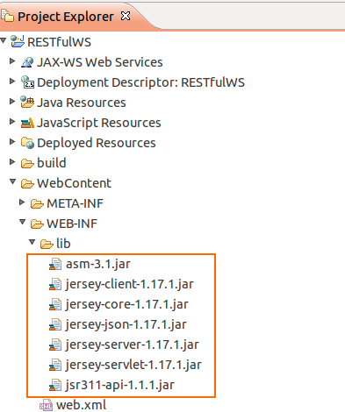

- In your project, inside Java Resources -> src create a new package called "com.eviac.blog.restws". Inside it create a new java class called "UserInfo". Also include the given web.xml file inside WEB-INF folder. UserInfo.java
package com.eviac.blog.restws;
import javax.ws.rs.GET;
import javax.ws.rs.Path;
import javax.ws.rs.PathParam;
import javax.ws.rs.Produces;
import javax.ws.rs.core.MediaType;

/**
*
* @author Garun Mishra
*
*/

// @Path here defines class level path. Identifies the URI path that
// a resource class will serve requests for.
@Path("UserInfoService")
public class UserInfo {

// @GET here defines, this method will method will process HTTP GET
// requests.
@GET
// @Path here defines method level path. Identifies the URI path that a
// resource class method will serve requests for.
@Path("/name/{i}")
// @Produces here defines the media type(s) that the methods
// of a resource class can produce.
@Produces(MediaType.TEXT_XML)
// @PathParam injects the value of URI parameter that defined in @Path
// expression, into the method.
public String userName(@PathParam("i") String i) {

String name = i;
return "<User>" + "<Name>" + name + "</Name>" + "</User>";
}

@GET
@Path("/age/{j}")
@Produces(MediaType.TEXT_XML)
public String userAge(@PathParam("j") int j) {
int age = j;
return "<User>" + "<Age>" + age + "</Age>" + "</User>";
}
}
web.xml To run the project, right click on it and click on run as ->run on server.
- Execute the following URL in your browser and you'll see the output.
view plain print ?
  - http://localhost:8080/RESTfulWS/rest/UserInfoService/name/Pavithra
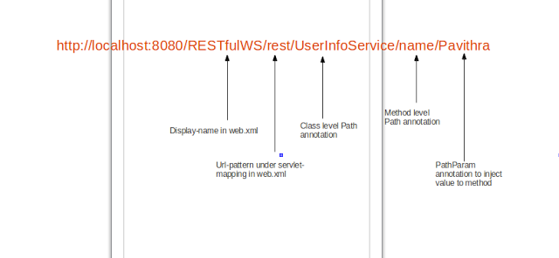
output
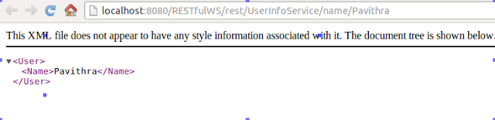
Creating Client
- Create a package called "com.eviac.blog.restclient". Inside it create a java class called "UserInfoClient".

Spring MVC Restful Web Services Simple Example:

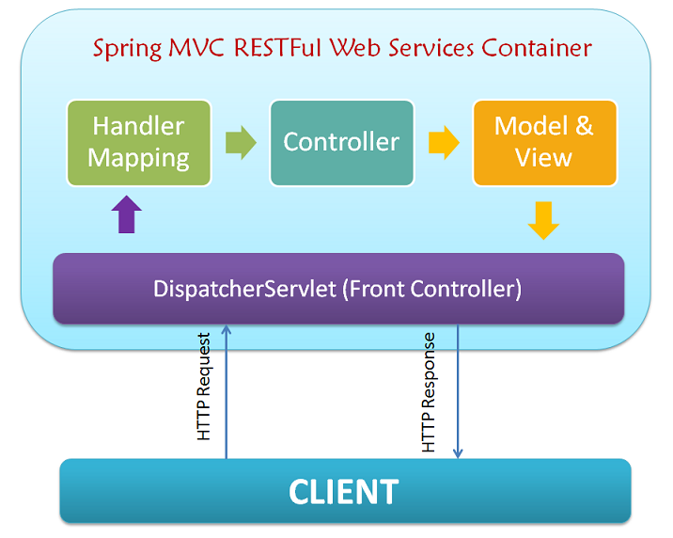

=>REST is an architectural style with which web services can be designed that serves resources based on the client.
=>A web Service is a unit of managed code that can be invoked using HTTP Request.
=> As per the architecture:
i) Client application issues request to web services in the form of URI's.
Like : http://localhost:8080/SpringRest/customers/201
ii)All HTTP requests are intercepted by DispatcherServlet which is front controller. This front controller is defined in web.xml file.
iii)DispatcherServelt looks for handlerMapping. Spring supports three ways of Mapping request URI to controller: Annotation, naming conventions, and explicit mapping. Handlermapping section is defined in application context file, tells Dispatcher Servlet which strategy to use to find the controllers based on the incomming requests.
iv) After that Requests are now processed by Controller and responce is returned to DispatcherServlet. Dispatcher Servlet is looks for ViewResolver section in the application context file. For Restful Web Services where your web controller return ModelView Object or View Name, “ContentNegotiatingResolver” is used to find the correct data representation format.
v) There is an alternate option to the above steps, Instead of forwardingModelAndView object from controller you can directly return the data from controller using @ResponseBody annotation as depicted below.

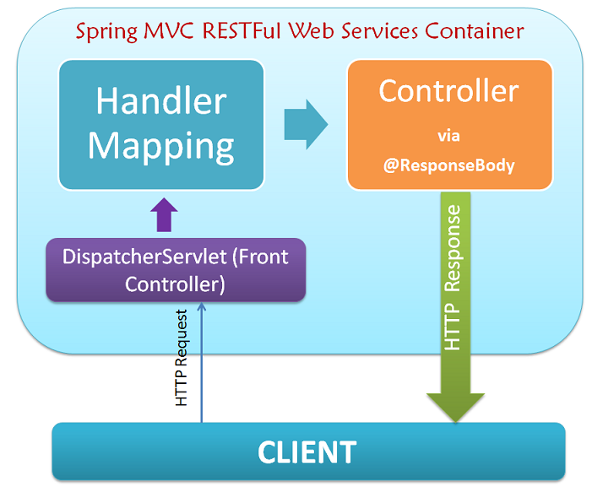

Create Restful java client with Java.net.URL

/**
*
*/
package com.crunchify.client;

import java.io.BufferedReader;
import java.io.InputStreamReader;
import java.net.URL;
import java.net.URLConnection;
import java.nio.charset.Charset;

/**
* @author Garun
*
*/
public class CrunchifyRESTJerseyNetURLClient {

/**
* @param args
*/
public static void main(String[] args) {
System.out.println(" \n ===================Output=================== \n "+callURL("http://localhost:8080/CrunchyRESTJerseyExample/crunchify/ctofservice/"));
}
public static String callURL(String myURL){
System.out.println("Requested URL is : "+myURL);
StringBuilder sb = new StringBuilder();
URLConnection urlConn = null;
InputStreamReader isr = null;
try{
URL url = new URL(myURL);
urlConn = url.openConnection();
if(urlConn != null)
urlConn.setReadTimeout(60*1000);
if(urlConn != null && urlConn.getInputStream() != null){
isr = new InputStreamReader(urlConn.getInputStream(), Charset.defaultCharset());
BufferedReader bufferReader = new BufferedReader(isr);
if(bufferReader != null){
int cp;
while((cp = bufferReader.read())!= -1){
sb.append((char)cp);
}
bufferReader.close();
}
}
isr.close();
}catch(Exception e ){
throw new RuntimeException("Exception while calling URL is : "+myURL, e);
}

return sb.toString();
}

}

